**Supplementary Information for the manuscript titled:  
Performance Assessment of Various Graph Neural Network Architectures for Predicting Yield in Cross-Coupling Reactions**

***Figure S1***. Comparison of Root Mean Square Error (RMSE) and Mean Absolute Error (MAE) values across different GNN models

for yield prediction in transition metal-catalyzed cross-coupling reactions.

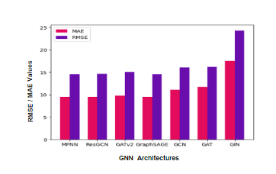

***Table S1*.** Comparison of graph-based models (GAT, GCN, GIN, and GraphSAGE) evaluated under various hyperparameter configurations. Performance metrics (R², RMSE, MAE) are reported for different combinations of learning rates (0.001, 0.0002, 0.005), epochs (50, 100), and hidden dimensions (32, 64, 128).

|  |  |  |  |  |  |  |  |  |  |  |
| --- | --- | --- | --- | --- | --- | --- | --- | --- | --- | --- |
| MODEL | EPOCHS | **0.001** | TEST R2 | TRAIN R2 | **0.002** | TEST R2 | TRAIN R2 | **0.005** | TEST R2 | TRAIN R2 |
| **MPNN** |  | 32 | 0.47 | 0.57 | 32 | 0.68 | 0.86 | 32 | 0.743 | 0.90 |
|  | 50 | 64 | 0.7492 | 0.90 | 64 | 0.7491 | 0.89 | 64 | 0.747 | 0.90 |
|  |  | 128 | 0.738 | 0.89 | 128 | 0.7506 | 0.90 | 128 | 0.7437 | 0.9029 |
|  |  |  |  |  |  |  |  |  |  |  |
|  | 100 | 32 | 0.74 | 0.89 | 32 | 0.7458 | 0.90 | 32 | 0.74 | 0.90 |
|  |  | 64 | 0.749 | 0.90 | 64 | 0.747 | 0.90 | 64 | 0.748 | 0.90 |
|  |  | 128 | 0.748 | 0.90 | 128 | 0.748 | 0.905 | 128 | 0.747 | 0.906 |

|  |  |  |  |  |  |  |  |  |  |  |
| --- | --- | --- | --- | --- | --- | --- | --- | --- | --- | --- |
| **ResGCN** |  | 32 | 0.75 | 0.93 | 32 | 0.74 | 0.92 | 32 | 0.75 | 0.93 |
|  | 50 | 64 | 0.741 | 0.91 | 64 | 0.747 | 0.93 | 64 | 0.748 | 0.937 |
|  |  | 128 | 0.7488 | 0.93 | 128 | 0.7488 | 0.93 | 128 | 0.7480 | 0.93 |
|  |  |  |  |  |  |  |  |  |  |  |
|  | 100 | 32 | 0.7480 | 0.93 | 32 | 0.7487 | 0.93 | 32 | 0.7490 | 0.93 |
|  |  | 64 | 0.7481 | 0.9356 | 64 | 0.7488 | 0.9362 | 64 | 0.7489 | 0.9374 |
|  |  | 128 | 0.7485 | 0.9369 | 128 | 0.7487 | 0.9377 | 128 | 0.7483 | 0.93 |
| **GraphSAGE** |  | 32 | 0.736 | 0.902 | 32 | 0.7502 | 0.931 | 32 | 0.7511 | 0.933 |
|  | 50 | 64 | 0.7494 | 0.93 | 64 | 0.7499 | 0.9365 | 64 | 0.7486 | 0.9373 |
|  |  | 128 | 0.748 | 0.937 | 128 | 0.747 | 0.936 | 128 | 0.7501 | 0.939 |
|  |  |  |  |  |  |  |  |  |  |  |
|  | 100 | 32 | 0.748 | 0.934 | 32 | 0.749 | 0.938 | 32 | 0.7488 | 0.9396 |
|  |  | 64 | 0.7491 | 0.9368 | 64 | 0.7492 | 0.9380 | 64 | 0.7493 | 0.9392 |
|  |  | 128 | 0.7494 | 0.9378 | 128 | 0.7492 | 0.9393 | 128 | 0.7480 | 0.9402 |
| **GCN** |  | 32 | -1.3340 | -1.2635 | 32 | -1.47 | -1.41 | 32 | 0.53 | 0.65 |
|  | 50 | 64 | -1.7112 | -1.6576 | 64 | 0.5126 | 0.6395 | 64 | 0.6993 | 0.8166 |
|  |  | 128 | 0.273 | 0.399 | 128 | 0.709 | 0.812 | 128 | 0.71 | 0.824 |
|  |  |  |  |  |  |  |  |  |  |  |
|  | 100 | 32 | -0.1688 | -0.0540 | 32 | 0.6064 | 0.7313 | 32 | 0.7130 | 0.8259 |
|  |  | 64 | -0.4660 | -0.3612 | 64 | 0.7140 | 0.8258 | 64 | 0.7136 | 0.8261 |
|  |  | 128 | 0.7027 | 0.8190 | 128 | 0.7139 | 0.8261 | 128 | 0.7147 | 0.8264 |
| **GAT** |  | 32 | 0.3839 | 0.5144 | 32 | 0.7041, | 0.8682 | 32 | -0.0850 | 0.0183 |
|  | 50 | 64 | 0.6904 | 0.8519 | 64 | 0.0717 | 0.1834 | 64 | 0.2450 | 0.3636 |
|  |  | 128 | 0.4326 | 0.5665 | 128 | 0.6722 | 0.8302 | 128 | 0.3225 | 0.4456 |
|  |  |  |  |  |  |  |  |  |  |  |
|  | 100 | 32 | 0.4437 | 0.5782 | 32 | -0.2331 | -0.1351 | 32 | 0.0318 | 0.1371 |
|  |  | 64 | 0.6675 | 0.8251 | 64 | -0.0116 | 0.0944 | 64 | 0.6710 | 0.8298 |
|  |  | 128 | 0.4708 | 0.6068 | 128 | 0.4946 | 0.6313 | 128 | 0.6562 | 0.8118 |
| **GATV2** |  | 32 | 0.59 | 0.74 | 32 | 0.74 | 0.92 | 32 | 0.73 | 0.91 |
|  | 50 | 64 | 0.74 | 0.92 | 64 | 0.72 | 0.89 | 64 | 0.73 | 0.90 |
|  |  | 128 | 0.74 | 0.92 | 128 | 0.73 | 0.90 | 128 | 0.7068 | 0.91 |
|  |  |  |  |  |  |  |  |  |  |  |
|  | 100 | 32 | 0.73 | 0.90 | 32 | 0.62 | 0.84 | 32 | 0.66 | 0.87 |
|  |  | 64 | 0.71 | 0.91 | 64 | 0.73 | 0.90 | 64 | 0.72 | 0.93 |
|  |  | 128 | 0.744 | 0.9251 | 128 | 0.75 | 0.9367 | 128 | 0.719 | 0.923 |
| **GIN** |  | 32 | 0.4288 | 0.5085 | 32 | 0.4897 | 0.5336 | 32 | 0.4820 | 0.5355 |
|  | 50 | 64 | 0.5240 | 0.5657 | 64 | 0.5420 | 0.6021 | 64 | 0.4453 | 0.5181 |
|  |  | 128 | 0.5354 | 0.5779 | 128 | 0.5081 | 0.5482 | 128 | 0.4510 | 0.5175 |
|  |  |  |  |  |  |  |  |  |  |  |
|  | 100 | 32 | 0.4562 | 0.5570 | 32 | 0.4655 | 0.5620 | 32 | 0.4585 | 0.5479 |
|  |  | 64 | 0.5008 | 0.5962 | 64 | 0.5293 | 0.5714 | 64 | 0.5164 | 0.5500 |
|  |  | 128 | 0.5076 | 0.6016 | 128 | 0.5416 | 0.5936 | 128 | 0.4920 | 0.5308 |

***Figure S2.***Scatter plots showing predicted versus experimental reaction yields for each graph-based model (GAT, GCN, GIN, GraphSAGE) using their respective optimized hyperparameters. Each model was trained and evaluated under various configurations of learning rate(0.001,0.002,0.005), number of epochs(50,100), and hidden layer dimensions(32,64,128).

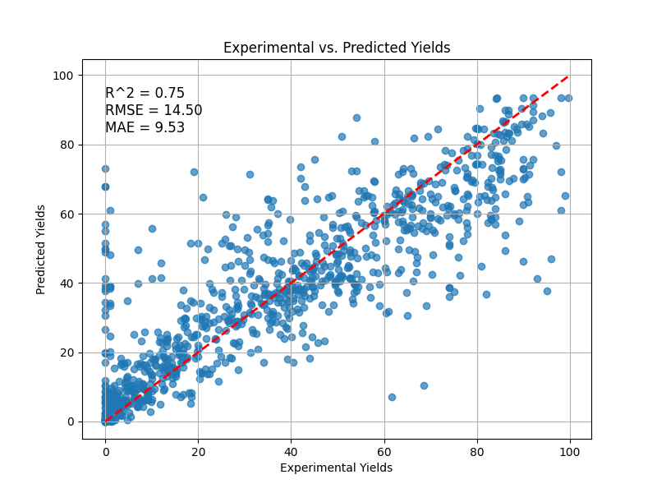 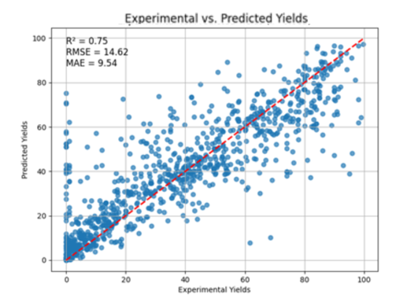

1. MPNN (B) RESGCN
2. 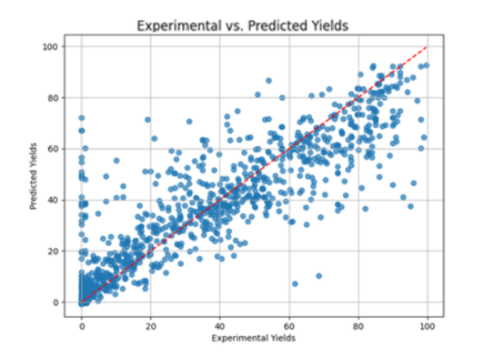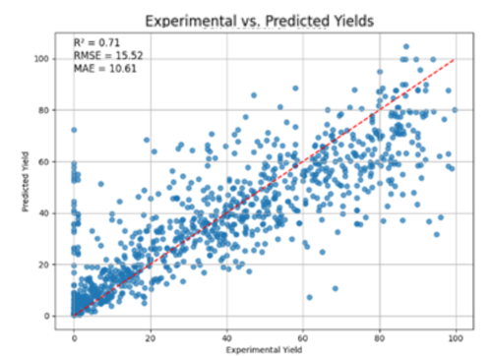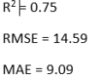 GraphSAGE (D) GCN

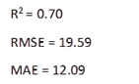 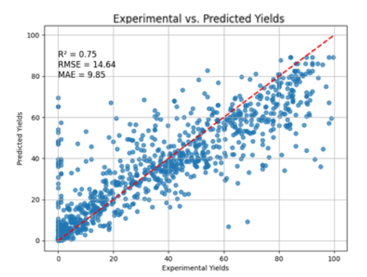

(E) GATV2 (F) GAT



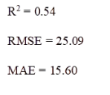

(G) GIN